Mallusk Harriers
Academy Sports Club, Mallusk Road,
Newtownabbey BT36 4QE
www.malluskharriers.co.uk
(Secretary) malluskharriers@outlook.com
(Membership Officer) mhmembership@outlook.com

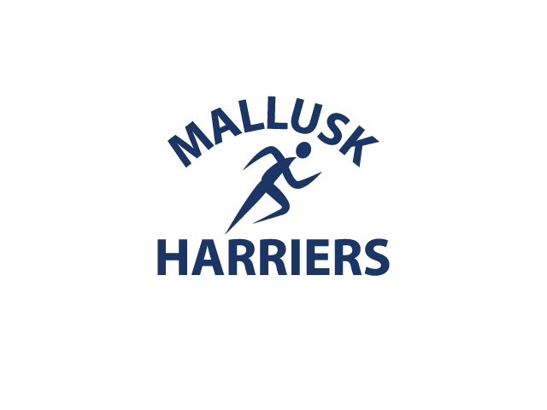
Membership
Application
2017/18

Completed forms can be returned via email to mhmembership@outlook.com or given to the Club Secretary or a Club Coach.

FEES can be paid in Cash, or via PayPal to mhmembership@outlook.com (when paying by PayPal, please select “SEND MONEY TO FRIENDS AND FAMILY” and ensure you enter the applicants name in the ‘Add a Note’ field and record your Transaction ID in section 3 below. Failure to do so may delay the processing of your membership).

All information provided on this form will be held in confidence. The Club Management and Coaches need to know these details in order to meet the specific needs of all members.

Mallusk Harriers reserves the right to refuse membership
- Personal Details
Name
Date of Birth |  | Country of Birth
Address | Postcode:
Mobile Telephone
Home Telephone
Email

- Emergency Contact Details
(Provide at least two persons who can be contacted in the event of an emergency)
Contact 1 |  | Contact 2
Name
Relationship to You
Home Telephone
Mobile Telephone

- Membership Type and Fee Structure
(Club Subscriptions provide registration and insurance charges from Athletics Northern Ireland and Club
expenses (ACCESS NI check / training courses). If you are not registered you will be UNABLE to compete,
volunteer or coach for Mallusk Harriers)
 | Membership Fee | Please tick and attach the relevant payment to this form, or note your PayPal transaction ID below
Minor (Under 11) | No fee
Junior (age 11 - age 17) | £5
Senior | £20

- Medical Information
(Please provide all relevant medical information to ensure the Club management is aware of your specific needs. Those wishing to compete are advised to list all medications currently prescribed to ensure all ANTI DOPING regulations are adhered to and EXEMPTION certificates can be sought.

If there is no relevant medical history please write “None”

As a member of Mallusk Harriers I agree to:
- Uphold Club rules as laid out in the Constitution, Codes of Conduct & Runner Safety. Copies are available on request and detailed on the Club website.
- Support all Club Officials at all times with loyalty, effort and enthusiasm.
- Help and encourage all fellow athletes and ensure that everyone is afforded the opportunity to enjoy their sport in a safe and friendly environment.
- Protect Club property and other equipment.

Member Signature
[for email replies], please type your name here
Date

- Parent or Guardian
(only to be completed by the parent or guardian of Minors & Juniors)
Parent or Guardian (PRINT NAME) |  |  |  |  | Relationship to Member Applying:
Telephone Number |  |  | Email
Parent or Guardian Signature
[for email replies], please type your name here

- Publicity Statement
Consent: I hereby give permission for myself / son / daughter to be photographed or video recorded by/or on behalf of the Club for promotional and/or training purposes. This includes Articles for local newspapers the club website and social media.
Signature
[for email replies only], please type your name here

Administration Only
ANI Number
Membership Payment Date
Membership Type

